**A CRM APPLICATION FOR WHOLESALE RICE MILL**

The Rice Mill CRM Application is a comprehensive solution designed to streamline and simplify how much rice per day, how many were sold that rice and which type of rice all reports send to owners daily wise. It leverages the power of customer relationship management (CRM) to enhance customer experiences, optimize store operations, and improve overall efficiency in the rice mill factory. This project aims to develop a user-friendly and feature-rich application that addresses the specific needs of a rice mill factory

***Milestone 1: Account Creation:***

***Activity 1: Creating Developer Account:***

Created A Developer account:

User Name: [project@cmrit.com](mailto:project@cmrit.com)

Email Id: [amarkamtala@gmail.com](mailto:amarkamtala@gmail.com)

Last Name: Amareshwar

First Name: Kamtala.

## ***Activity 2: Account Activation:***

Verified the account and Activated the account.

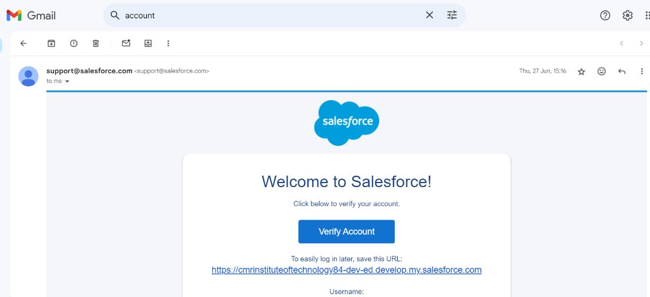

The Home page of the salesforce is as follows.

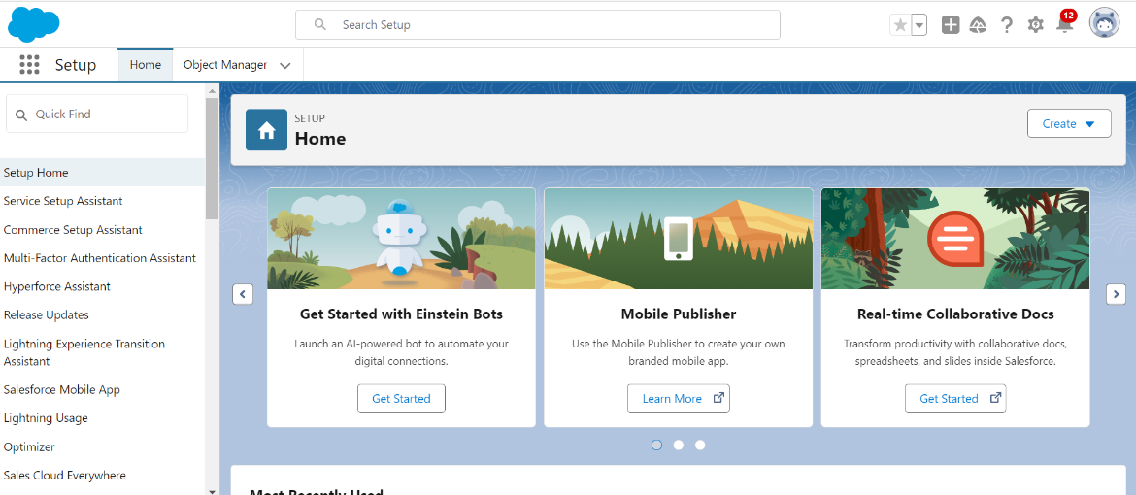

# ***Milestone 2- Object***

## ***Activity 1: Create Supplier Object:***

I Created a custom object under the name Supplier. The details of the object is as follows

label name : **supplier**

plural label name : supplier

Record Name → supplier Name

Data Type → Text

## ***Activity 2: Create Rice mill Object:***

I Created a custom object under the name Rice mill. The details of the object is as follows. label name : rice mill

Plural label name : rice mills

Enter Record Name Label and Format

* Record Name →
* Data Type → Auto Number
* Display Format → rice-{000}
* Starting number → 1

## ***Activity 3: Create consumer Objects:***

Created a consumer object using these datails.

Using these display format for the  **consumer**

* label name →  **consumer**
* Plural label name →  **consumers**
* Display Format →  **consumers**-{000}
* Starting number → 1

## ***Activity 4: Create rice details Objects:***

## Created a rice details object using the details

Using these display format for the rice details

* label name → rice details
* Plural label name → rice details
* Display Format → rice-{000}
* Starting number → 1

# ***Milestone 3- Tabs***

## ***Activity 1: Creating a Custom Tab***

**To create a Tab:( supplier)**

* Go to setup page → type Tabs in Quick Find bar → click on tabs → New (under custom object tab)
* Select Object( supplier) → Select the tab style → Next (Add to profiles page) keep it as default → Next (Add to Custom App) uncheck the include tab .
* Make sure that the Append tab to users' existing personal customizations is checked.
* Click save.

## ***Activity 2: Creating Remaining Tabs***

In the same way I created tabs for the remaining objects they are rice mill, rice details and consumers.

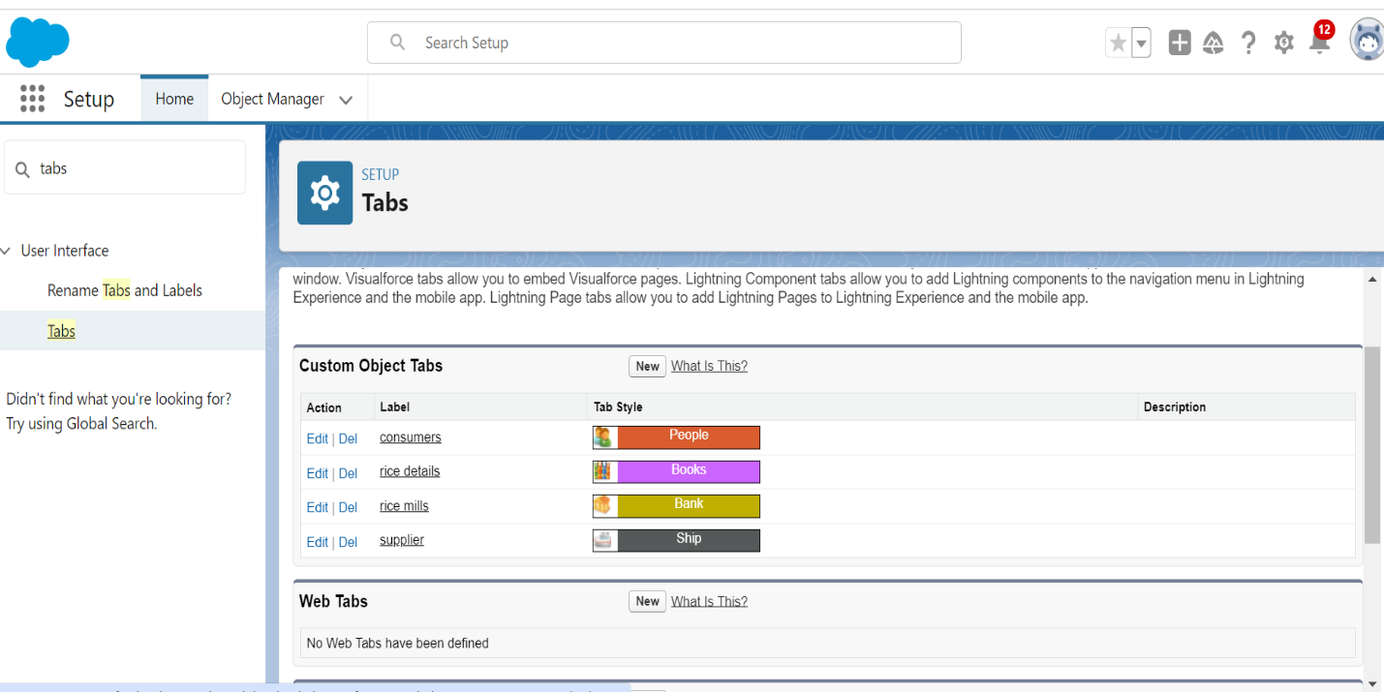

***Milestone 4- The Lightning App:***

## ***Activity 1: Create a Lightning App***

**To create a lightning app page:**

* Go to setup page and search for “app manager” in quick find → select “app manager” → click on New lightning App.
* Fill the app name in app details as MY RICE →Next → (App option page) keep it as default → Next → (Utility Items) keep it as default → Next.
* Upload a photo that is related to your app.
* To Add Navigation Items:  
  Select the items (supplier, rice mill, consumer, Rice details ) from the search bar and move it using the arrow button → Next.
* To Add User Profiles

Search profiles (System administrator) in the search bar → click on the arrow button → save & finish.

# ***Milestone 5 : Fields***

## ***Activity 1: Creating the number field in rice details object***

**Creating the number field in rice details object**

* Go to the setup page → click on object manager → From drop down click edit for rice details object.
* Click on fields & relationship → click on New.
* Select Data type as “Number” and click Next.
* Given the Field Label as “ rice distributed ” and length as “ 5 ”.
* Field Name will be auto populated, and click on Next→ Next → Save.

## ***Activity 2 : Creating Junction Object :***

**Creating junction object as rice details with supplier & rice mill**

To create junction object

* Go to the setup page → click on object manager → From drop down click edit for rice details object.
* Click on fields & relationship → click on New.
* Select “Master-Detail relationship” as data type and click Next.
* Select the related object “ supplier ” and click next.
* Give Field Label as “supplier Name” and click Next.
* Next → Next → Save & New.
* Follow the same steps from 1 to 3.
* Select the related object “ rice mill ” and click Next.
* Give Field Label as “rice mill 1(one)” and click Next.
* Next → Next → Save.

## ***Activity 3 : Creating a Master-Detail Relationship***

**Creating Master-Detail Relationship between consume**r **& rice mill Object**

To Create a Master-Detail relationship

* Go to the setup page → click on object manager → From drop down click edit for consumer object.
* Click on fields & relationship → click on New.
* Select “Master-Detail relationship” as data type and click Next.
* Select the related object “ rice mill”.
* Give Field Label as “rice mill name” and click Next.
* Next → Next → Save.

## **Activity 4 : Creating the Roll-up Summary**

## **Creating the Roll-up summary field on supplier & rice mill Objects.**

* Go to setup → click on Object Manager → type object name(supplier) in search bar → click on the object.
* Now click on “Fields & Relationships” → New
* Select the data type as “Rollup summary ”,and click Next.
* Give the Field label as “ sum of rice distributed ”,Field Name will be Auto generated, and click Next.
* Select the summarized object as “ rice details ”.
* Select the Rollup type as “sum”.
* Select the field to aggregate as “ rice distributed ”, and click Next → Next → Save.
* Follow the same steps for the rice mill Object from 1 to 3
* Give the Field label as “ rice distributed to shops ”,Field Name will be Auto generated, and click Next.
* Select the summarized object as “ rice details ”.
* Select the Rollup type as “sum”.
* Select the field to aggregate as “ rice distributed ”, and click Next → Next → Save.
* **Note :** create the field as “ rice taken by shops in kgs” using number datatype in consumer object
* Follow the same steps for the rice mill Object from 1 to 3
* Give the Field label as “ rice taken ”,Field Name will be Auto generated, and click Next.
* Select the summarized object as “ consumer”.
* Select the Rollup type as “sum”.
* Select the field to aggregate as “ rice taken in shops ”, and click Next → Next → Save.

.

## ***Activity 5 : Creating Fields in Objects***

**Creating the number field in rice details object**

* Go to the setup page → click on object manager → From drop down click edit for rice details object.
* Click on fields & relationship → click on New.
* Select Data type as “Number” and click Next.
* Given the Field Label as “ supplier name ” and length as “ 5 ”.
* Field Name will be auto populated, and click on Next→ Next → Save.

## ***Activity 6: Creating Fields in rice mill Objects***

* Select Data type as “Number” and click Next.
* Given the Field Label as “ rice price/kg ” and length as “ 5 ”.

## **Activity 7: Creating Fields in consumer Objects**

|  |  |  |
| --- | --- | --- |
| S.no | Object name | Fields data type |
| 1. | consumer | |  |  | | --- | --- | | First name | Text | | Last name | Text | | Phone number | phone | | email | email | | Rice taken by shops | Number (length=5) | | Rice type | (Picklist values)  1.basmati  2.normal rice | | Mode of payment | Picklist values   * Credit card * Debit card * Net banking * UPI * Cash | |

***Activity 8 : Creating Cross Object Formula Field in consumer Object***

**Note :** check whether the fields mentioned in the formula field are created or not , if not go to activity 9 and create those fields mentioned in consumer object.

* Go to setup → click on Object Manager → type object name(consumer) in search bar → click on the object.
* Click on fields & relationship → click on New.
* Select Data type as “Formula” and click Next.
* Give Field Label and Field Name as “Amount Paid ” and select formula return type as “Number” and click next.
* Insert fields formula should be :

rice_taken_by_shops__c * rice_mill_name__r.rice_price_kg__c

* Under Advanced Formula write down the formula and click “Check Syntax” and Save.

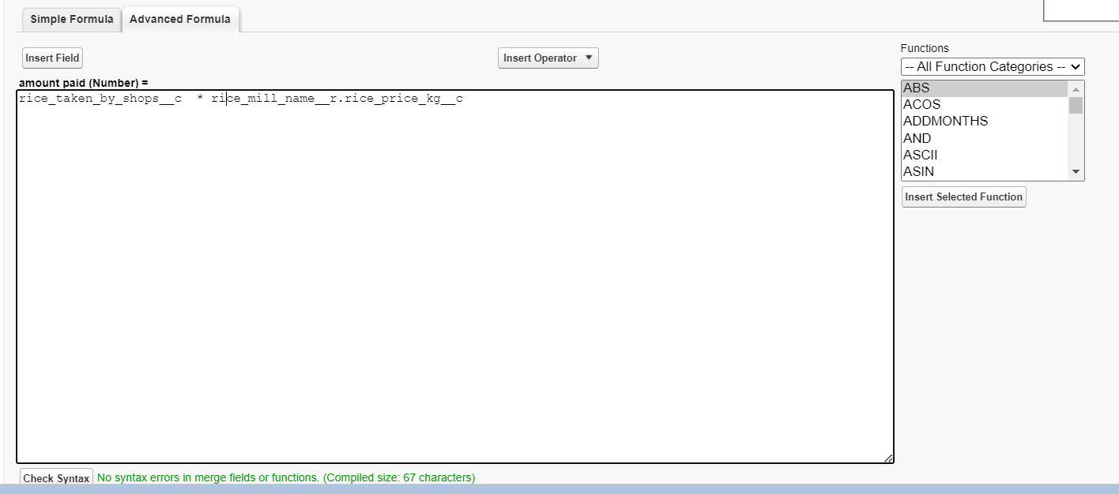**Creating the Formula field in consumer Object**

**Note :** check whether that the fields that mentioned in the formula field are created are not , if not go to activity 9 and create that fields mentioned in consumer object

* Go to setup → click on Object Manager → type object name(consumer) in search bar → click on the object.
* Click on fields & relationship → click on New.
* Select Data type as “Formula” and click Next.
* Give Field Label and Field Name as “Consumer Name” and select formula return type as “TEXT” and click next.
* Insert field formula should be : First_Name__c + ' ' + Last_Name__c
* click “Check Syntax” and Save.
* 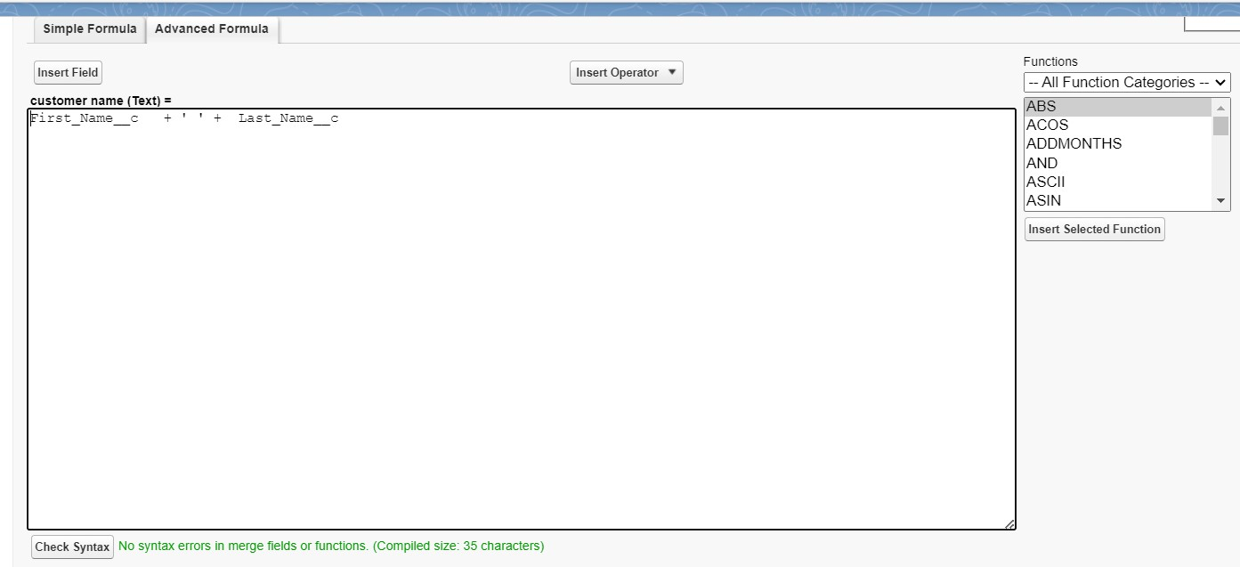

## ***Activity 9 : Creating the validation rule***

**Creating the validation rule for phone number field in consumer object**

**Note :** check whether the fields mentioned in the formula field are created or not , if not go to activity 9 and create those fields mentioned in consumer object.

* Go to the setup page → click on object manager → From drop down click edit for consumer object.
* Click on the validation rule → click New.

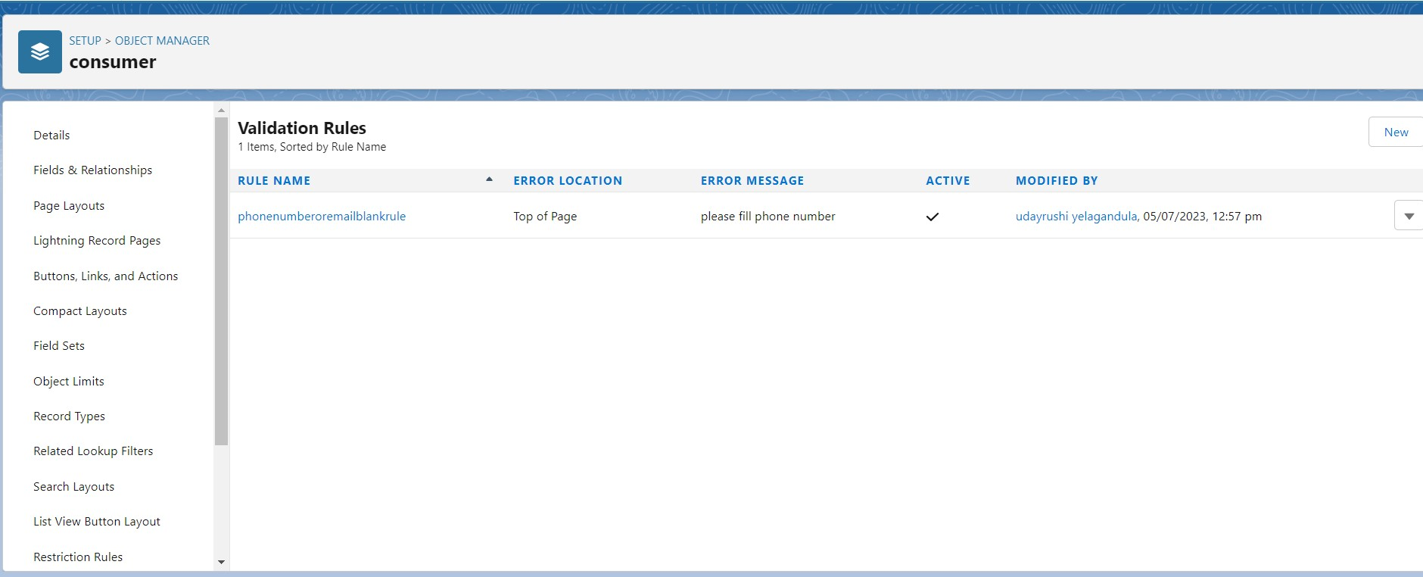

* Enter the Rule name as “Phonenumberoremailblankrule ”.
* Enter the description as “phone number and email number should not be blank”.
* Enter the formula as “OR( ISBLANK( phone_number__c ) , ISBLANK( email__c ) )” and check the syntax.
* Under the error message write as”please fill in your phone number.”
* Select error location “top of page”.
* Save the validation rule.

# ***Milestone 6 : Page layouts***

# ***Activity 1 : creating the page layout***

**To Create a Page layout:**

* Go to Setup → Click on Object Manager → Search for the object (consumer) → From drop down select the object and click on it.
* Click on Page layout → Click on New.
* Select the existing page layout, and give the page layout name as “consumer layout”, and click save.

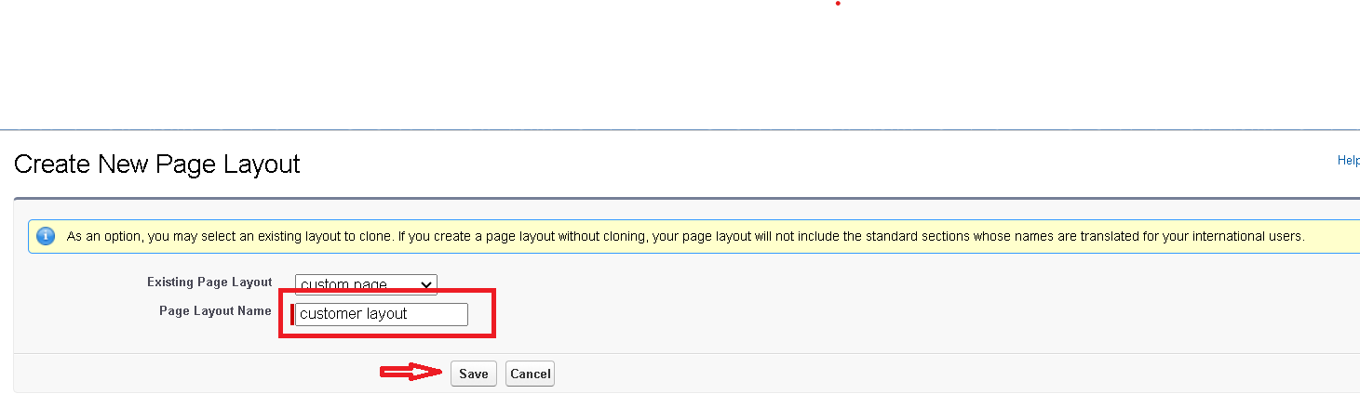

* Drag and drop the section field to consumer details and create the section.
* Enter the section name as “Personal details”, → click Ok.

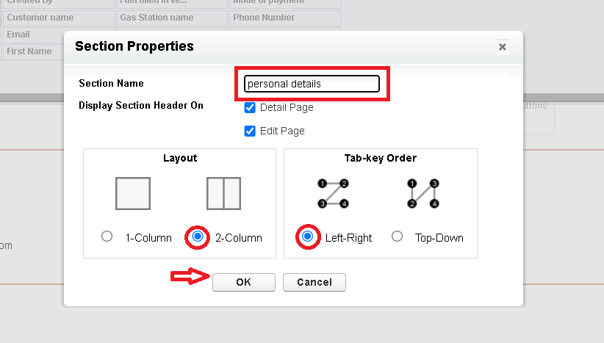

* Now drag the fields to this section that mentioned , they are
* First name , last name , consumer name , phone number, email, rice mill name.
* Follow the same process for another two sections as shown above , they are
* One section is “ rice details ” , drag the fields that are
* Rice taken by shop, rice type.
* Another section is “Receipt details ”, and drag the fields that are
* Mode of payment , Amount paid.
* Then , Click save.
* 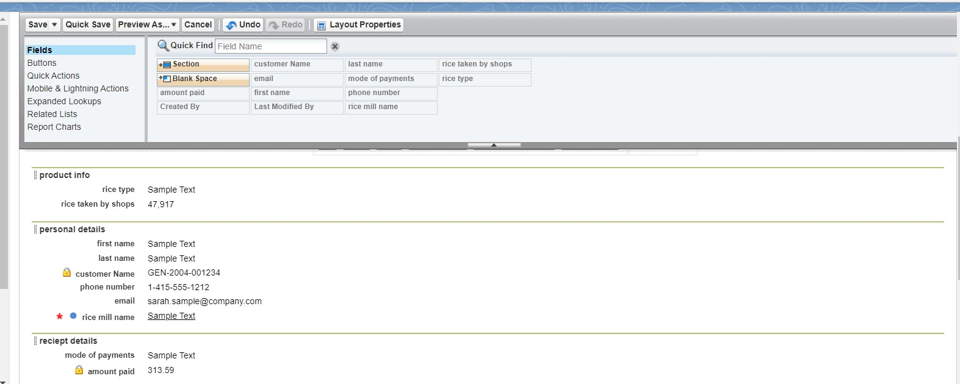

# ***Milestone 7 : Profiles***

## ***Activity 1: Owner Profile***

**To create a new profile:**

* Go to setup → type profiles in quick find box → click on profiles → clone the desired profile (Standard User) → enter profile name (owner) → Save.
* Scroll down to Custom Object Permissions and Give access permissions for consumers, rice details , rice mill and suppliers objects as mentioned in the below diagram.
* Give access and save it.

## ***Activity 2: Employer Profile***

* Go to setup → type profiles in quick find box → click on profiles → clone the desired profile (Standard Platform User) → enter profile name (employer) → Save.
* While still on the profile page, then click Edit.
* Select the Custom App settings as default for the rice mill..
* Scroll down to Custom Object Permissions and Give access permissions for consumer, rice details , rice mill and suppliers objects as mentioned in the below diagram.

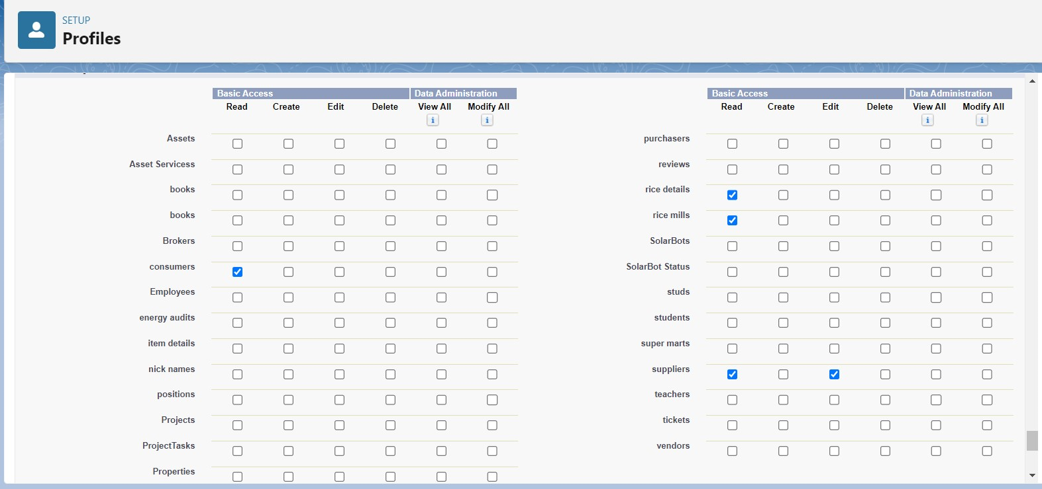

* And click save.

## ***Activity 3: Worker Profile***

* Go to setup → type profiles in quick find box → click on profiles → clone the desired profile (Standard Platform User) → enter profile name (worker) → Save.
* While still on the profile page, then click Edit.
* Select the Custom App settings as default for the rice mill.
* Scroll down to Custom Object Permissions and Give access permissions for consumer, rice details , rice mill and suppliers objects as mentioned in the below diagram.
* And click save.

# ***Milestone 8 : Role & Role Hierarchy***

## ***Activity 1: Creating Owner Role***

Creating owner Role:

* Go to quick find → Search for Roles → click on set up roles.
* Click on Expand All and click on add role under whom this role works.
* Give Label as “owner” and Role name gets auto populated. Then click on Save.
* Click and save it.

***Activity 2: Creating Employer roles***

Creating another two roles under manager

* Go to quick find → Search for Roles → click on set up roles.
* Click plus on CEO role, and click add role under owner.
* Give Label as “employer” and Role name gets auto populated. Then click on Save.
* Repeat the same steps, for another role.
* Click plus on CEO role, and click plus on owner, and click add role under employer.
* Give Label as “worker” and Role name gets auto populated. Then click on Save.

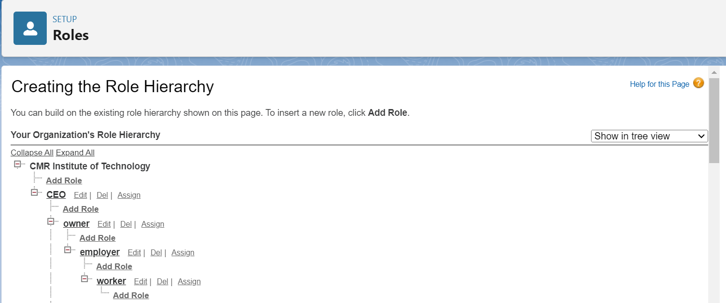

# ***Milestone 9 : Users***

## **Activity 1: Create User**

* Go to setup → type users in quick find box → select users → click New user.
* Fill in the fields

1. First Name : vicky
2. Last Name : y
3. Alias : vy
4. Email id : amarkamtala@gmail.com
5. Username : amarkamtala@gmail.com
6. Nick Name : vicky
7. Role : owner
8. User license : Salesforce
9. Profiles : owner.

Save it.

## ***Activity 2: Creating another users***

1. Go to setup → type users in quick find box → select users → click New user.
2. Fill in the fields

* First Name : ram
* Last Name : ram
* Alias : ram
* Email id : amarkamtala@gmail.com
* Username : amarkamtala18@gmail.com
* Nick Name : Ram
* Role : employer
* User license : Salesforce platform
* Profiles : standard platform user.

1. Go to setup → type users in quick find box → select users → click New user.
2. Fill in the fields

* First Name : ragu
* Last Name : raj
* Alias : raj
* Email id : amarkamtala@gmail.com
* Username : amarkamtala16@gmail.com
* Nick Name : Raj
* Role : worker
* User license : Salesforce platform
* Profiles : standard platform user.

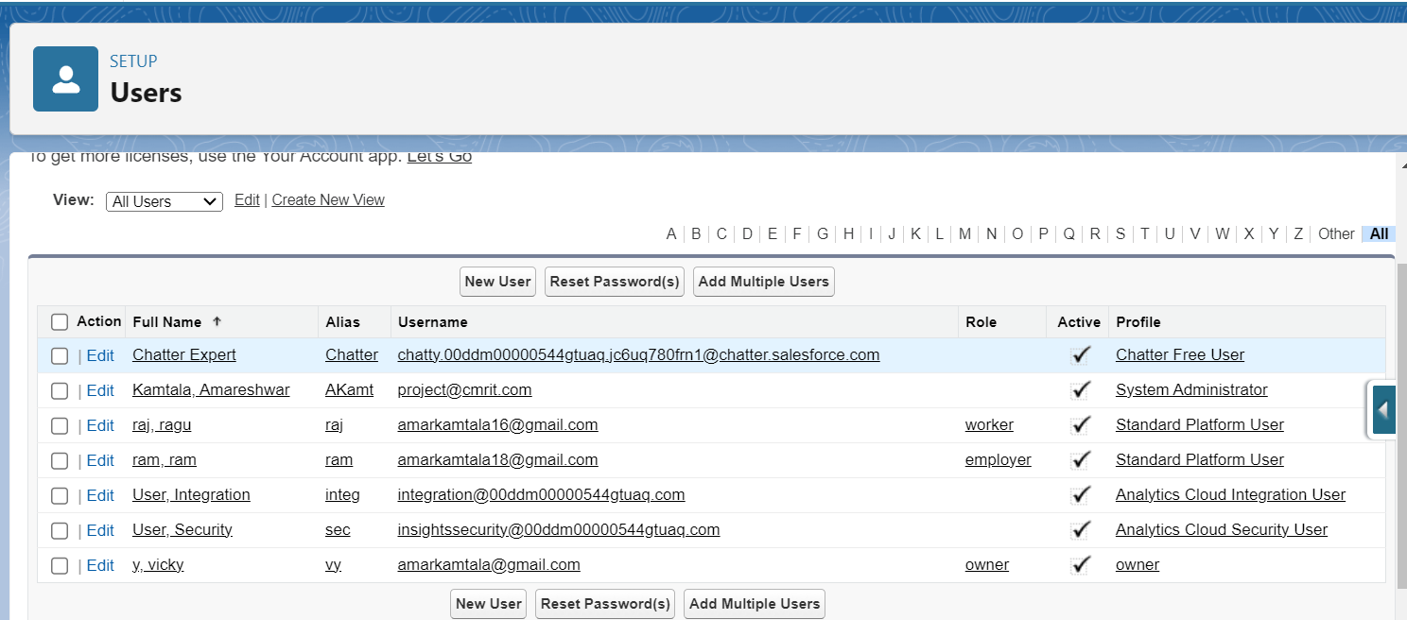

***Milestone 10 : Permission sets***

## ***Activity 1: Creating OWD setting.***

* Go to setup → type “sharing settings ” in quick search → Click edit.
* Scroll down, change the default internal access to “ public read-only” for rice mill and supplier object.
* Click save.
* Extra information, By these every profile has their own access, according to their profile.
* But in our case we created roles and given the roles in such a way that the owner can see employer and worker records , and the employer can see the worker records.

**Note : create the latest “10” records in consumer objects.**

**Try to fill every field in each record for better experience.**

# ***Milestone 11 : Reports***

## ***Activity 1: Create Report***

* Go to the app → click on the reports tab
* Click New Report.
* select for report type, search for “rice mill with consumers” click on it. And click on start report.
* Their outline pane is opened already, select the fields that are mentioned below in the column section.

1.consumer name

2.rice type

3.rice price/kg

4.mode of payments

5.amount paid

* Remove the unnecessary fields.
* Select the fields that are mentioned below in the GROUP ROWS section.
  1. Rice taken by shops.

Click save and run and save the report as “range of amount per day”.and save it.

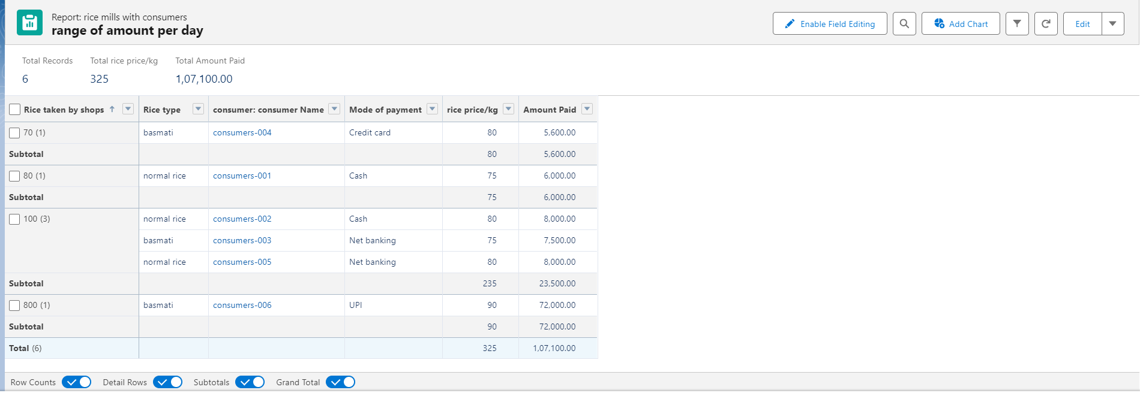

## ***Activity 2: Sharing report to owner***

* Click edit drop down and select subscribe option
* Follow as per below image.
* 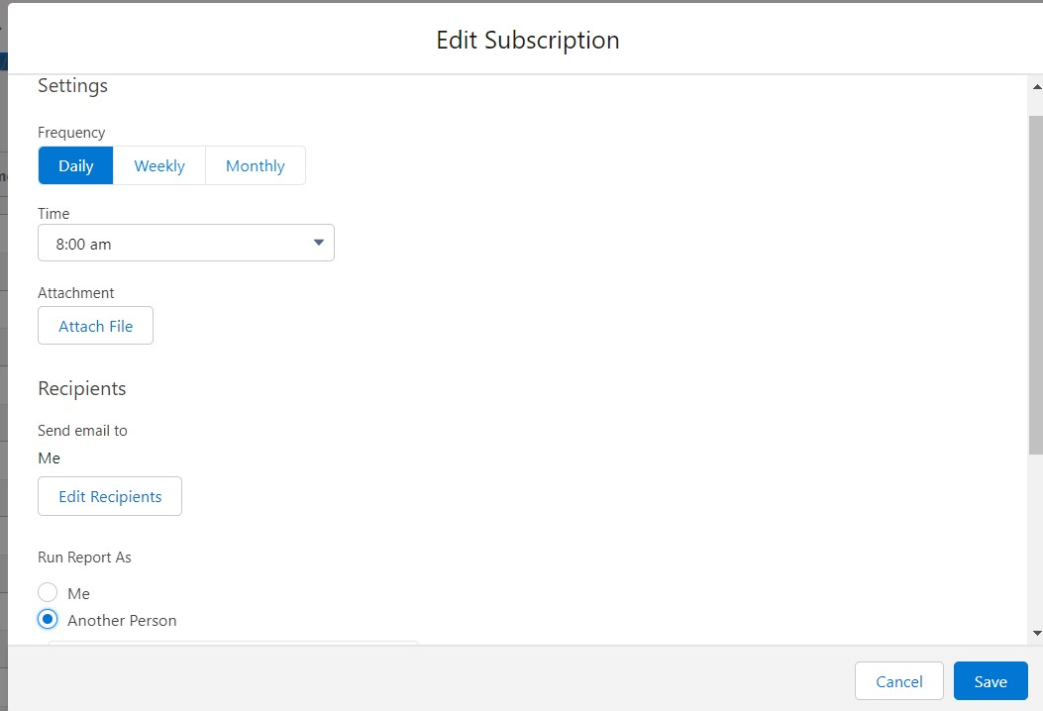
* After selecting the run report as a “another person” select your personal account or whom you want to send that mail to.
* Click save.

**Note**: The owner gets daily email notification of that rice mill report.so that he can see all data remotely.

## ***Activity 3: create a report folder***

* Click on the app launcher and search for reports.
* Double click on the report, “ reports tab” will be auto populated in the navigation bar.
* Click on the report tab, click on the new folder.
* Give the Folder label as “estimated rice per day ”, Folder unique name will be auto populated.
* Click save.
* Navigate to app launcher and click reports on that.
* Click all reports.
* Select the range of amount per day drop down in that click move.
* Select estimated rice per day folder and select folder.

**Note**: if you want to see the report which you have created then go to reports - all folders - estimated rice per day - your report will appear in this way.

# ***Milestone 12 : Dashboards***

## ***Activity 1: Create Dashboard Folder***

* Click on the app launcher and search for the dashboard.
* Click on the dashboard tab.
* Click the new folder, give the folder label as “ amount data dashboard”.
* Folder unique names will be auto populated.
* Click save.

## ***Activity 2: Create Dashboard***

* Go to the app → click on the Dashboards tabs.
* Give a Name and select the folder that was created, and click on create.
* Select add component.
* Select a Report and click on select.

1. Display as- vertical bar chart
2. X-axis - rice taken by shops
3. Y-axis- sum of amount
4. Y-axis range - automatic
5. Sort by - rice taken by shops
6. Component theme - dark.

* Add the component
* Again select add component with above same steps
* 1.display as donut chart
* 2.sort by - sum of amount
* 3.title-range of amount per day
* 4.component theme dark
* Click add.
* Click save and done.

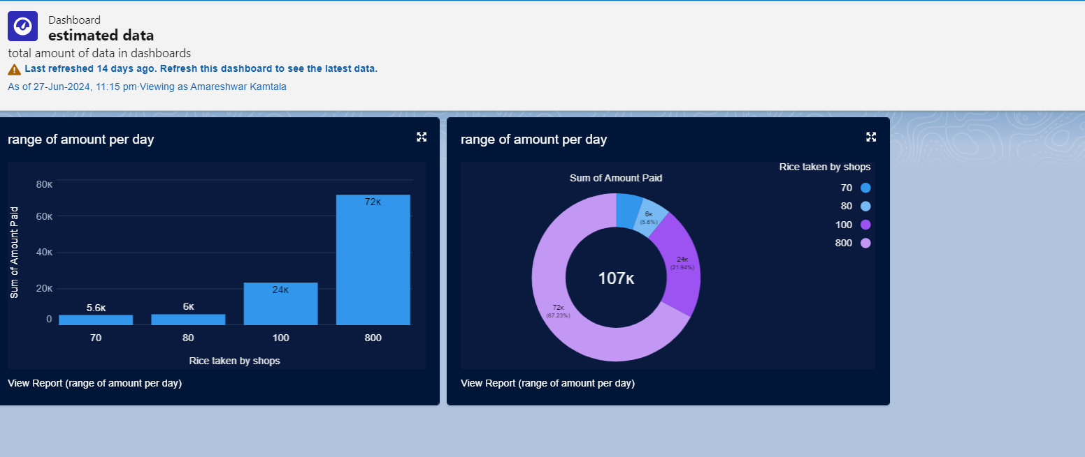

***Email Alerts:***

After Completing this project the owner would able to get the report of daily activities as a mail as follows:

